

|  |  |  |
| --- | --- | --- |
| **Module Code** | **:** | AAPP009-4-2-WDT – WEB DEVELOPMENT |
| **Intake Code** | **:** | UCDF2208ICT(SE) |
| **Lecturer Name** | **:** | MR MOHAMAD FIRDAUS CHE ABDUL RANI |
| **Tutorial No.** | **:** | T20 |
| **Group Leader** | **:** | Alvan Sew (TP072788) |
| **Project Title** | **:** | Charity Ease Malaysia |

|  |  |
| --- | --- |
| **Student ID** | **Student Name** |
| TP072535 | Tham King Joe |
| TP068941 | Enoch Kok Jia Xian |
| TP072665 | Wilson Tan Jun Yuan |
| TP072214 | Tancel Raj |

Contents

**No table of contents entries found.**

# Introduction

Charity Ease foundation is a charity foundation that is aimed towards helping those in their golden years live worry free and in comfort. We do this by collecting and donating funds to various old folks' homes with the intention of lifting their financial burdens and providing them with enough funds to better their facilities and spare no luxury from those who are nearing their end of life.

With that being said, our website allows registered customers to deposit funds into our website which will then be channelled to various old folks' homes. Customers will be able to change and edit their account profiles whenever they wish. Customers will also be able to provide feedback which will then be reviewed and used to improve our services.

# Design

## Entity Relationship Diagram

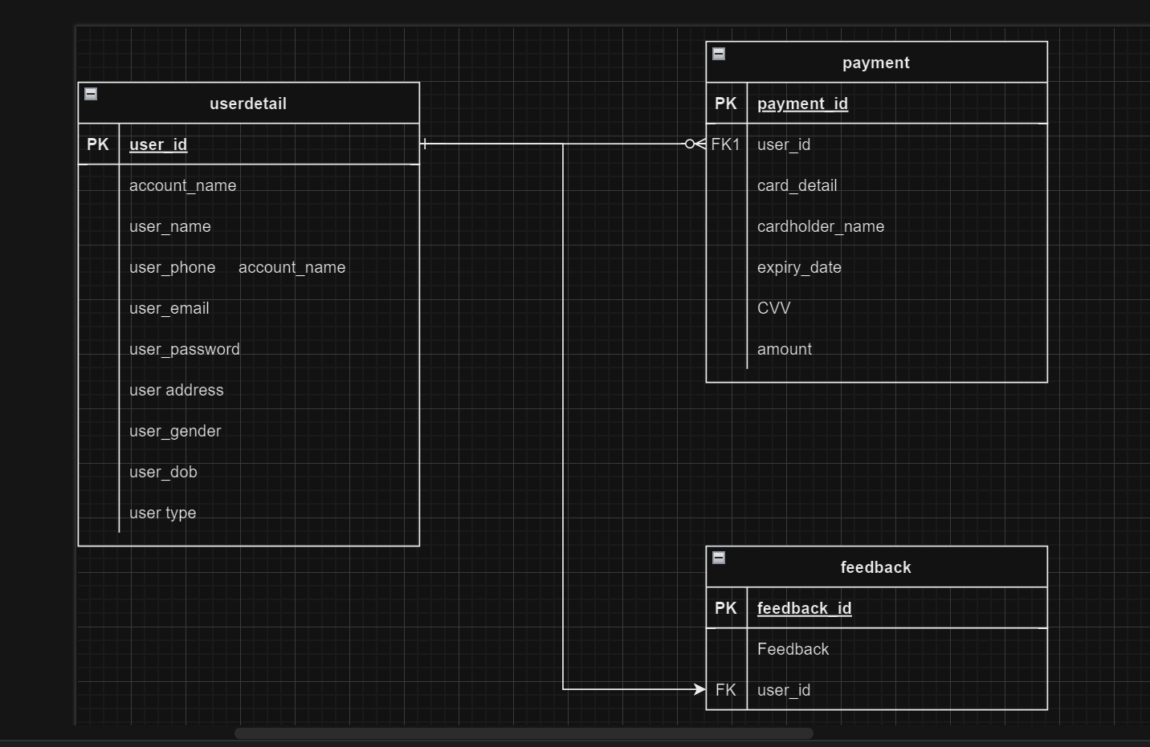

## Website Navigational Structure

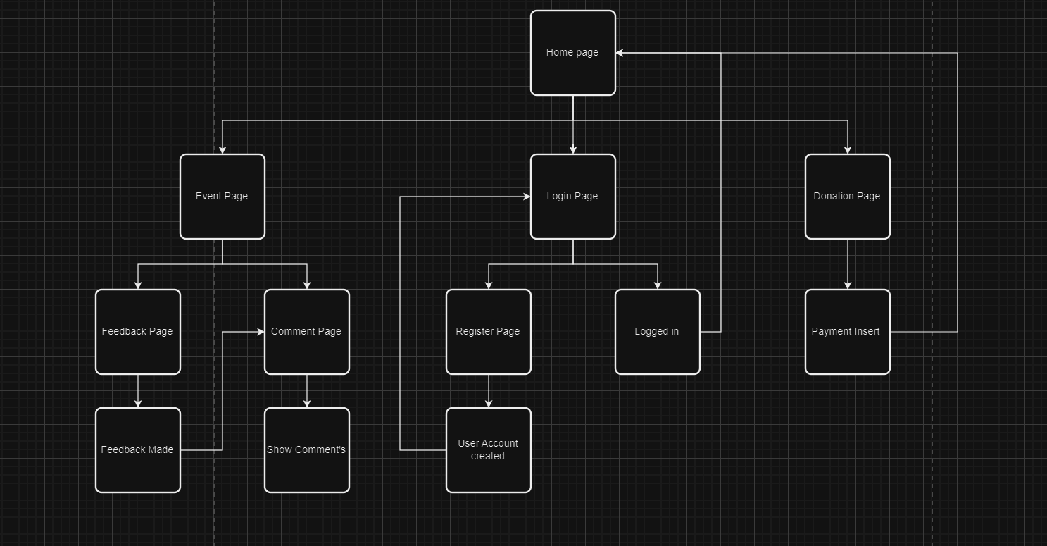

## Data Dictionary

|  |  |  |  |  |
| --- | --- | --- | --- | --- |
| Field Name | Data Type | Field Length | Constraint | Description |
|  |  |  |  |  |
| user_id | Int |  | Public Key | Id number of user |
| account_name | Varchar | 255 | Not Null | The identification that the user would prefer in the website |
| user_name | Varchar | 255 | Not Null | Name of user |
| user_phone | Varchar | 50 | Not Null | Phone number of user |
| user_email | Varchar | 255 | Not Null | Email address of user |
| user_password | Varchar | 50 | Not Null | Password of user |
| user_address | Text |  | Not Null | Address of user |
| user_gender | Varchar | 10 | Not Null | Gender of user |
| user_dob | Date |  | Not Null | Date of birth of user |
| user_type | varchar | 255 | Not Null | Use to identify whether user have logged in or not |
|  |  |  |  |  |
| payment_id | Int |  | Primary key | Id of payment made by user |
| user_id | Int |  | Foreign Key | Id number of user |
| card_detail | Varchar | 255 | Not Null | Card detail’s of user |
| cardholder_name | Varchar | 255 | Not Null | The name of the person who owns the card |
| expiry_date | Date |  | Not Null | Expiry date of the card |
| CVV | Int |  | Not Null | Card Verification Value of the card |
| amount | int |  | Not Null | The amount that the user would like to donate |
|  |  |  |  |  |
| feedback_id | int |  | Primary key | Id number of the comment made |
| feedback | text |  | Not Null | Contains the feedback that is given by the user. |

# Wire Frame

Before Login

In this section, the following shows a rough sketch of what the UI UX of the website, showing the location of all the buttons would have access to before the user have created an account in our website

Home Page

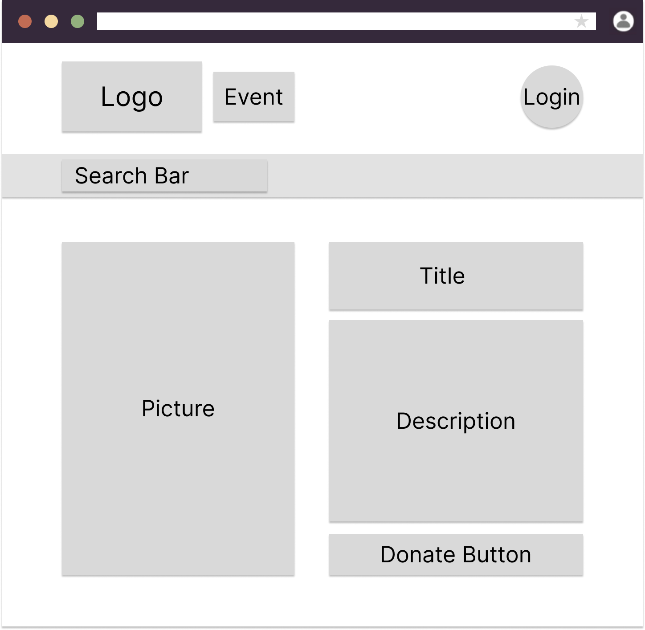

Event Page

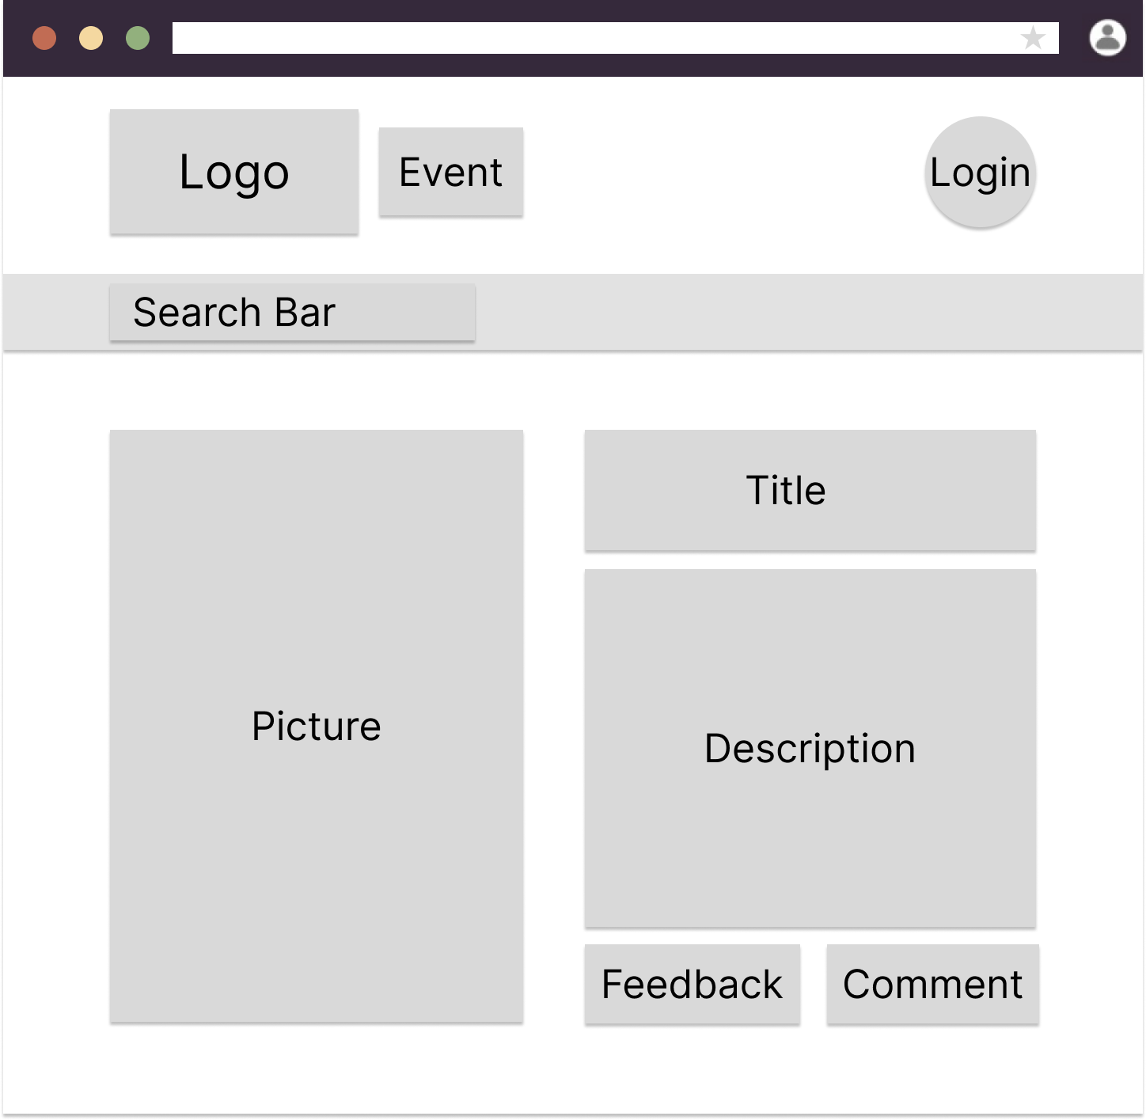

Login Page

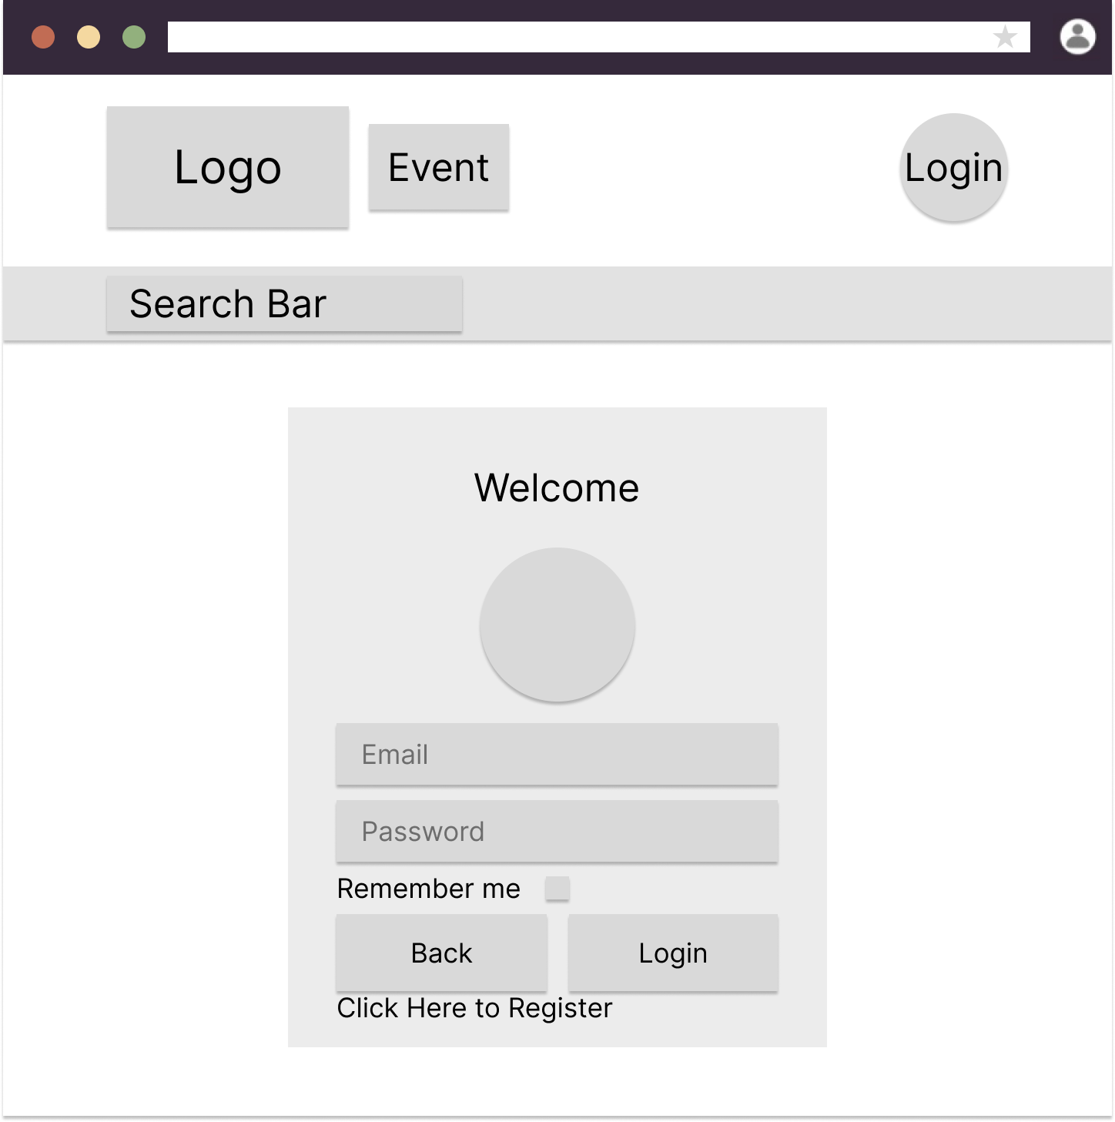

Register Page

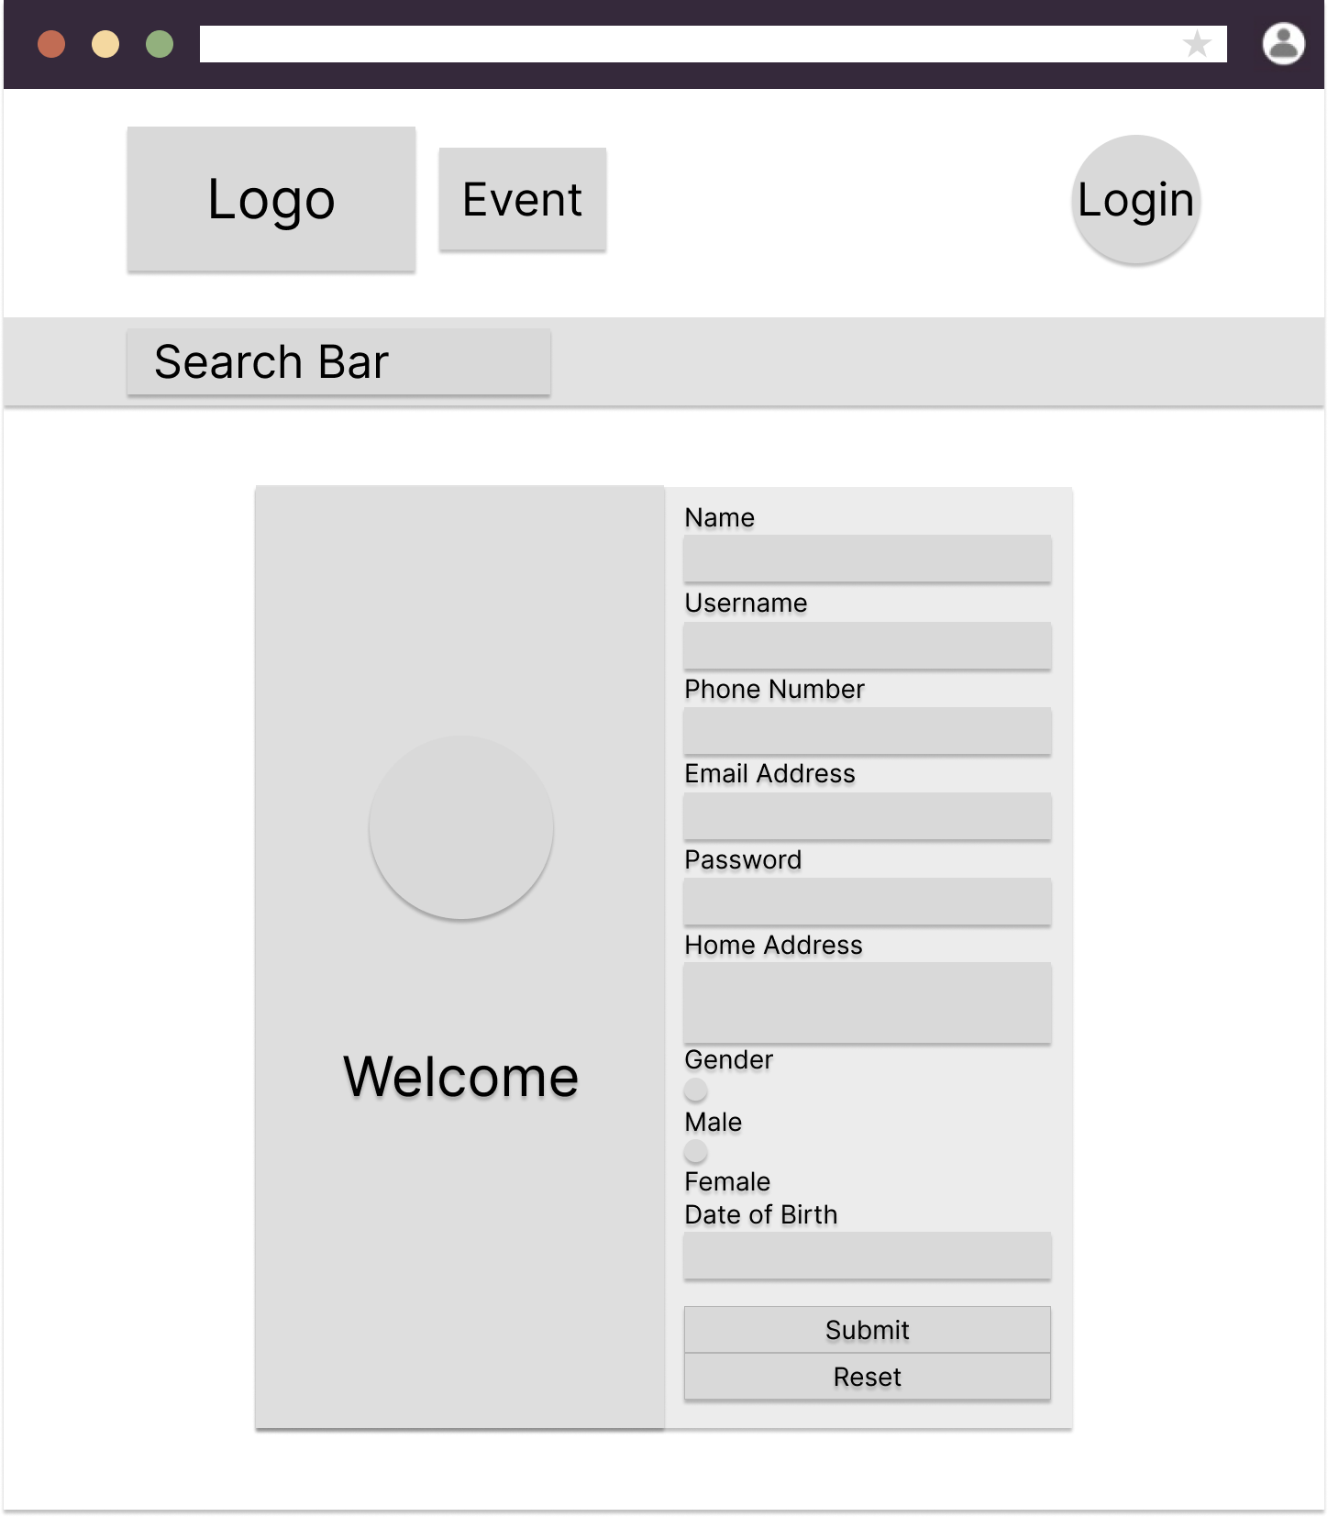

After Login

User Home Page

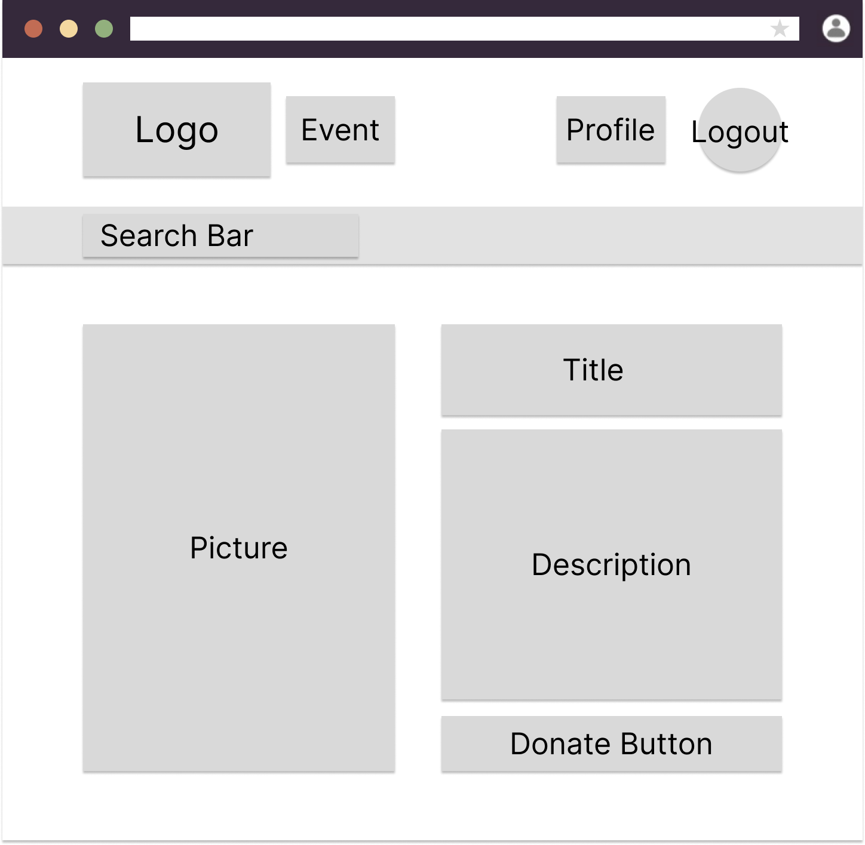

User Event Page

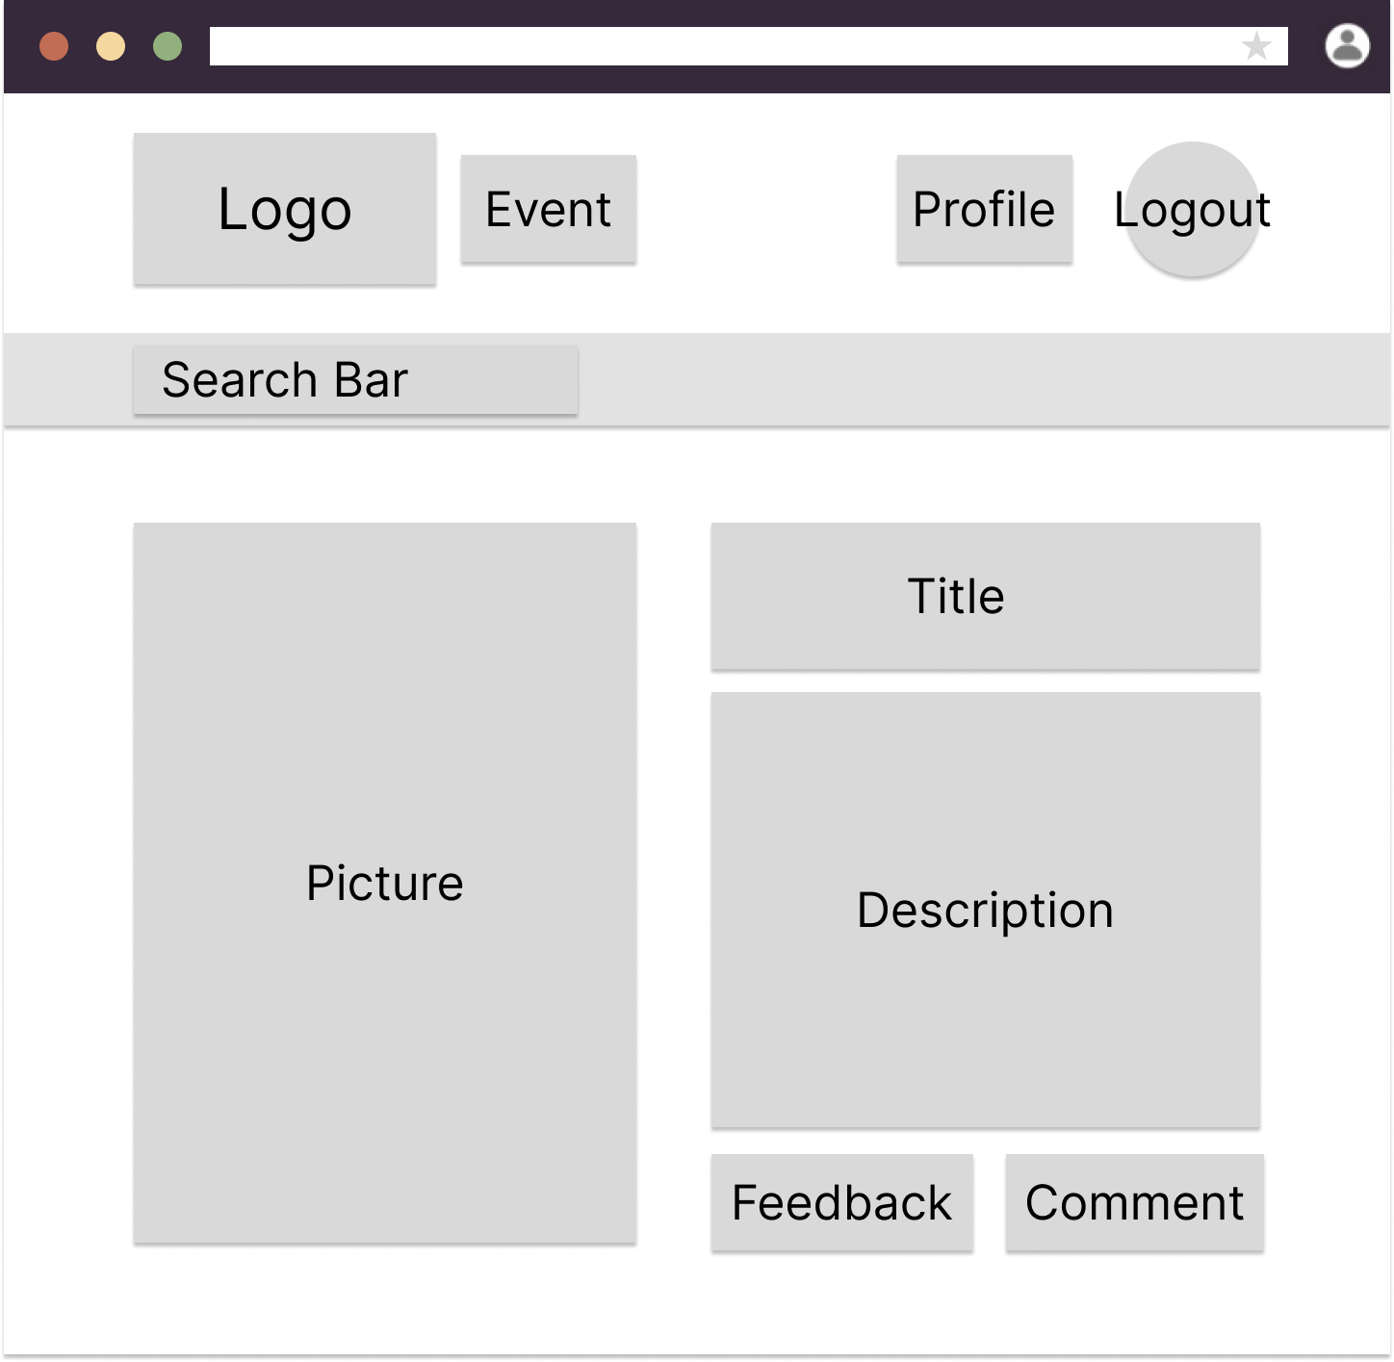

Donate Page

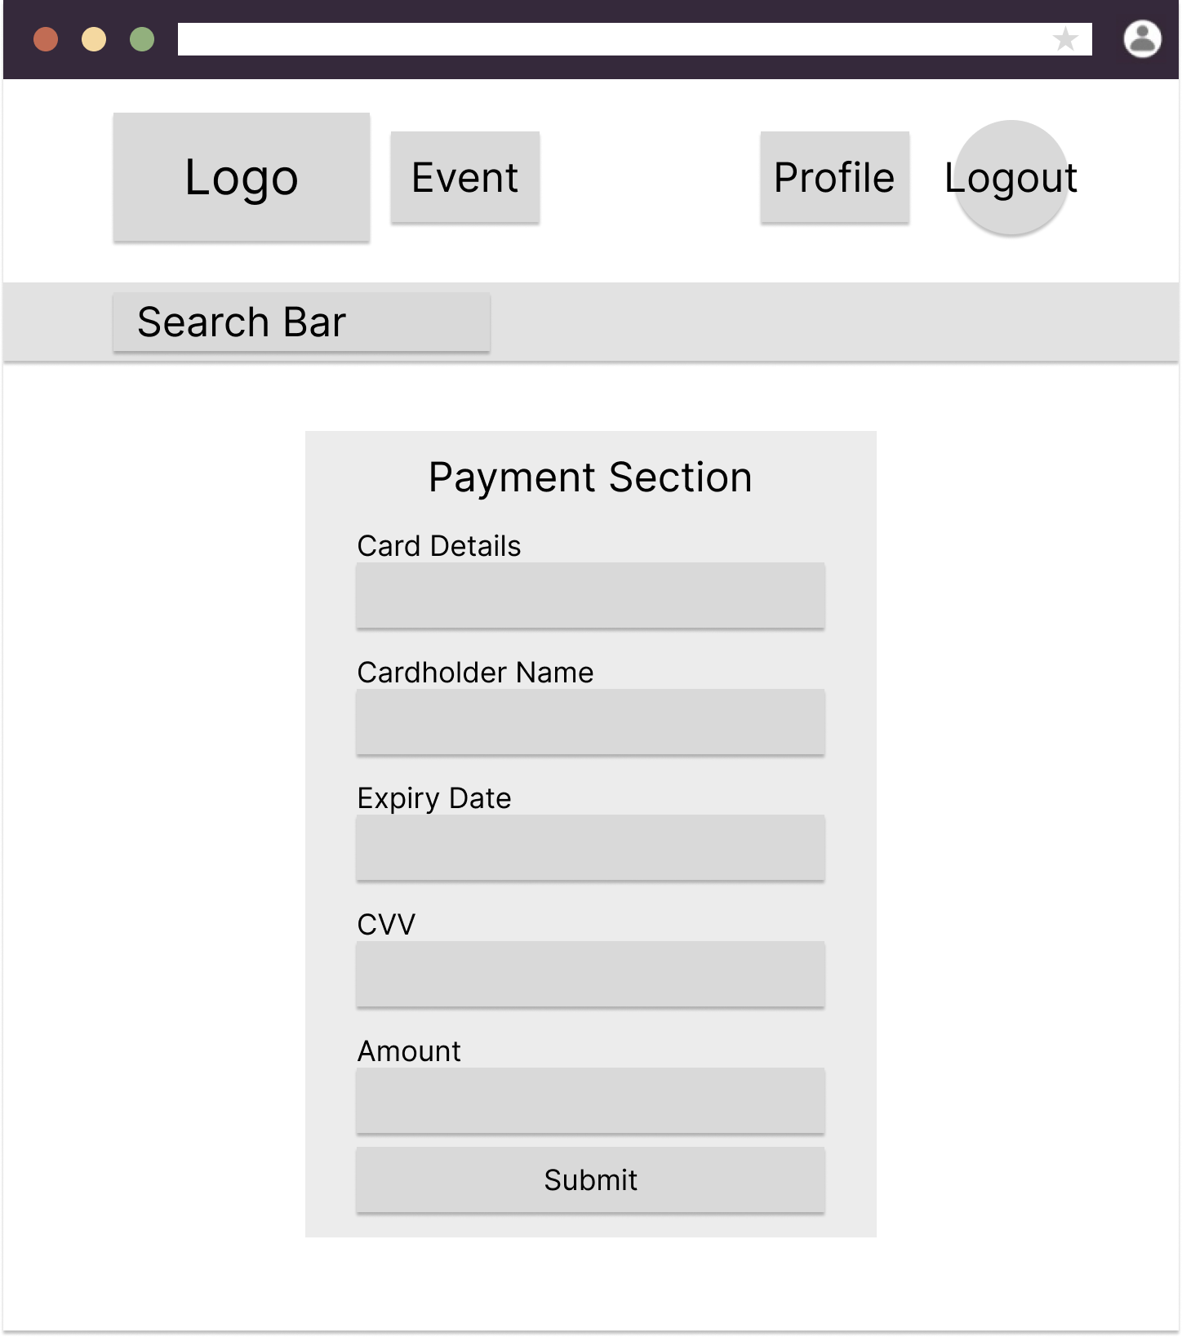

Feedback Page

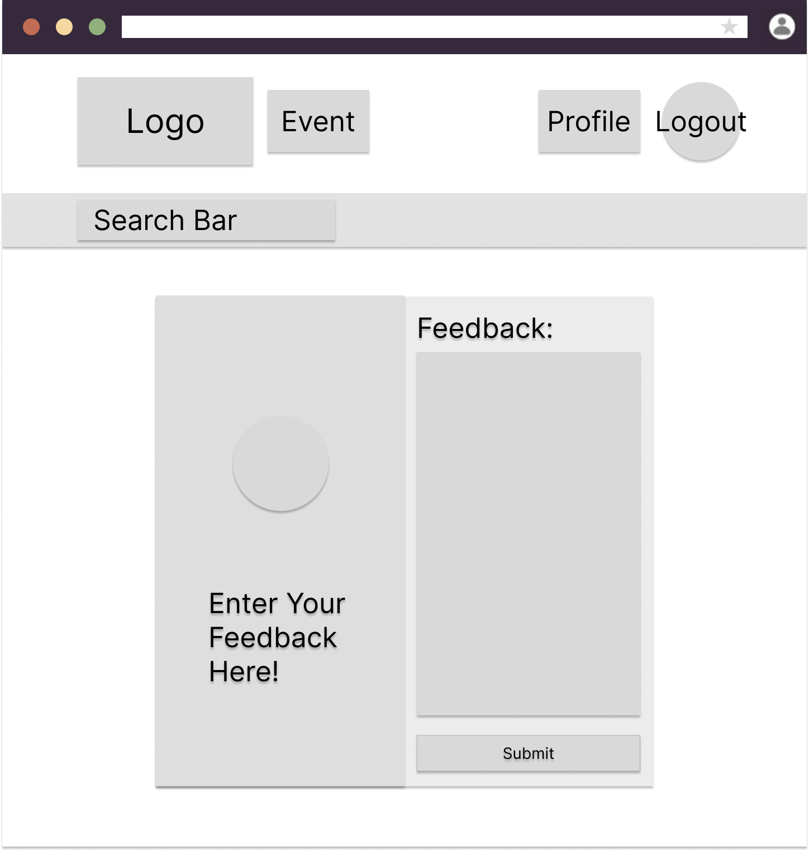

Comment Page

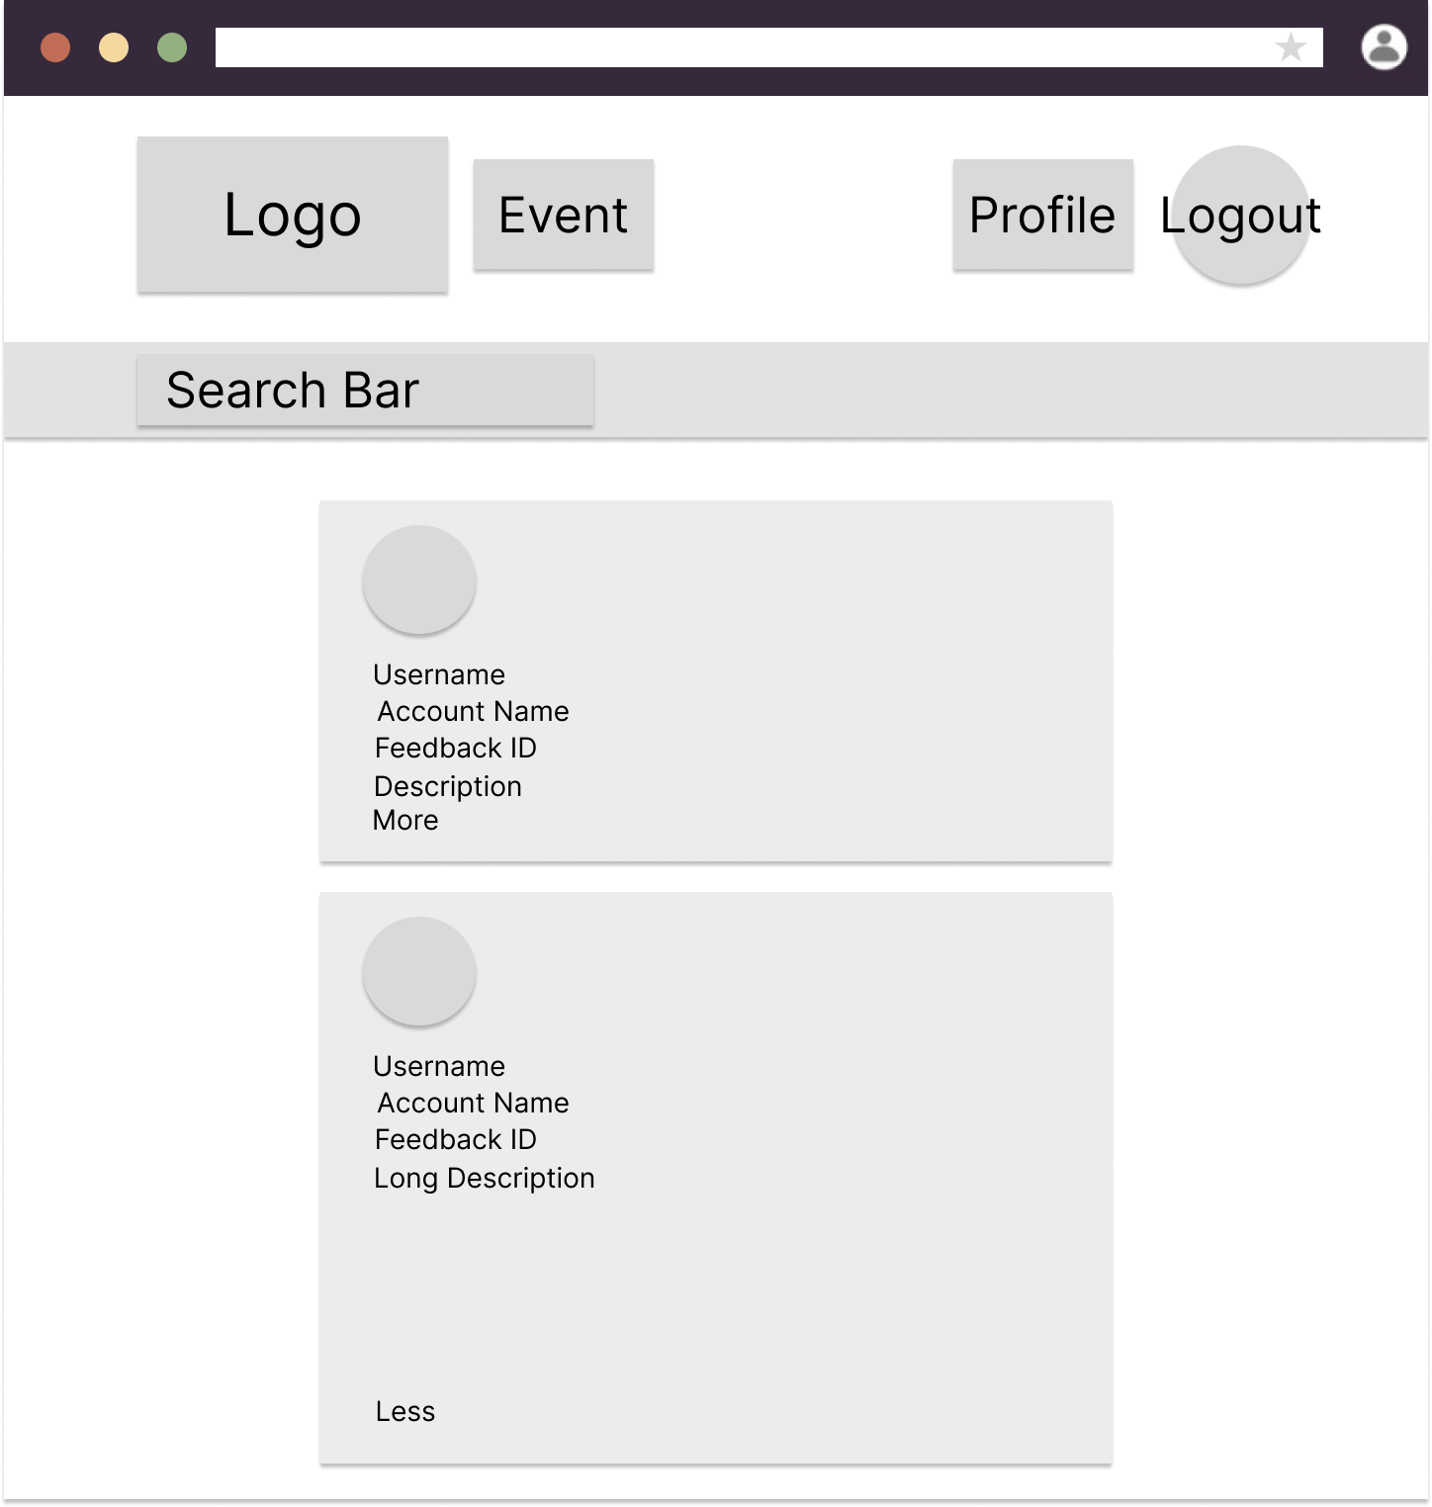

Admin

Admin View User Page

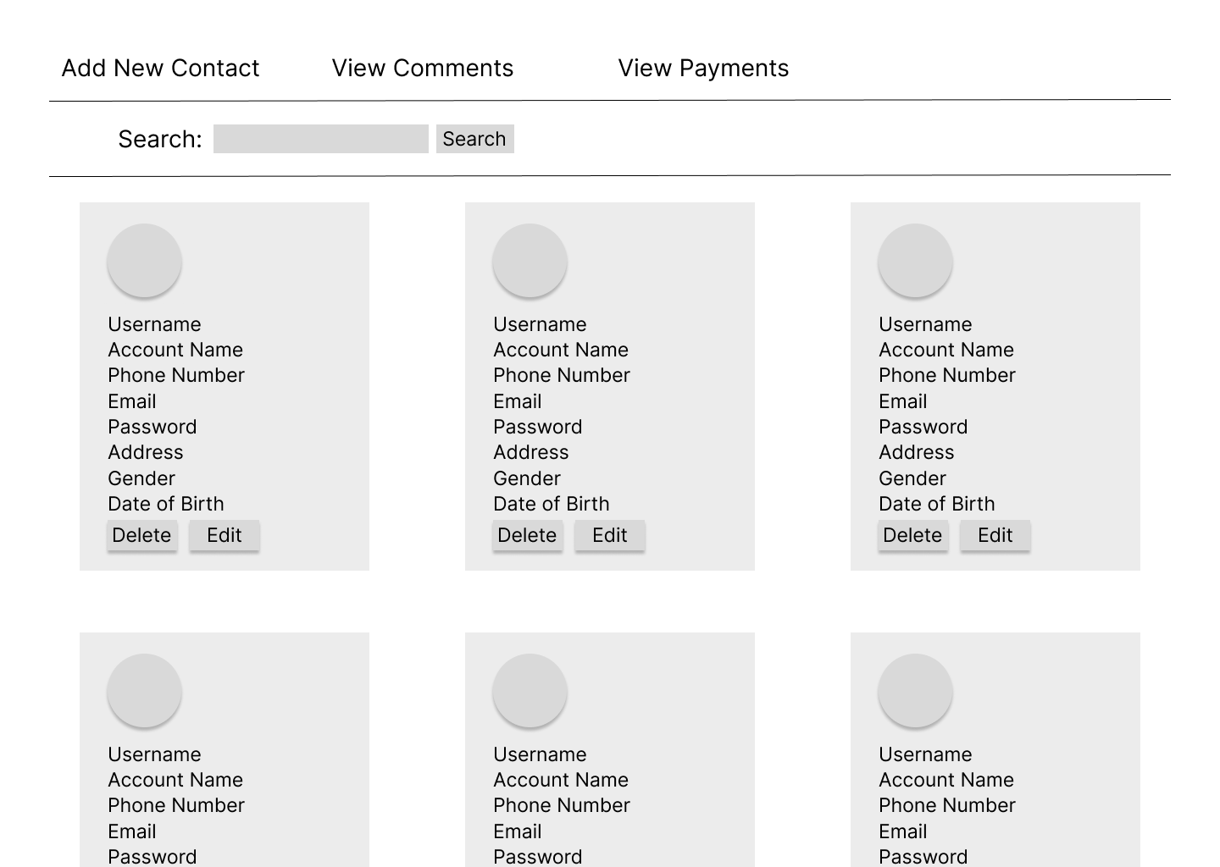

Admin View Comment Page

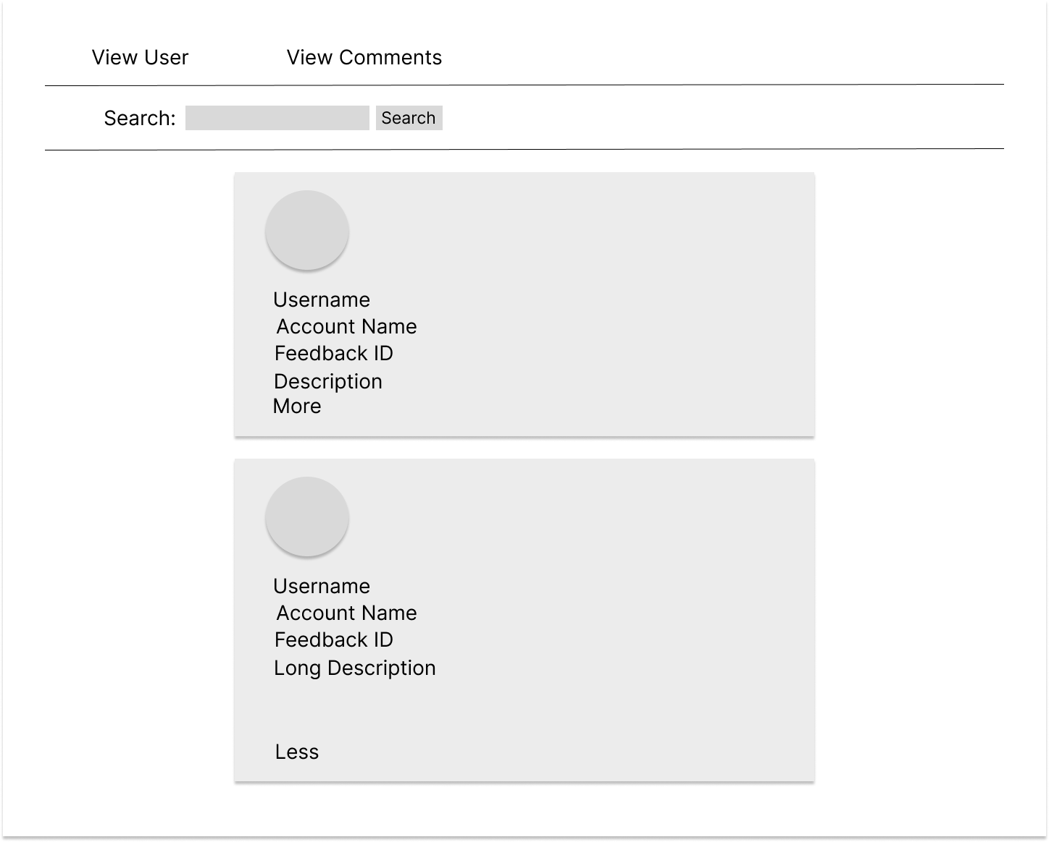

Admin View Payment Page

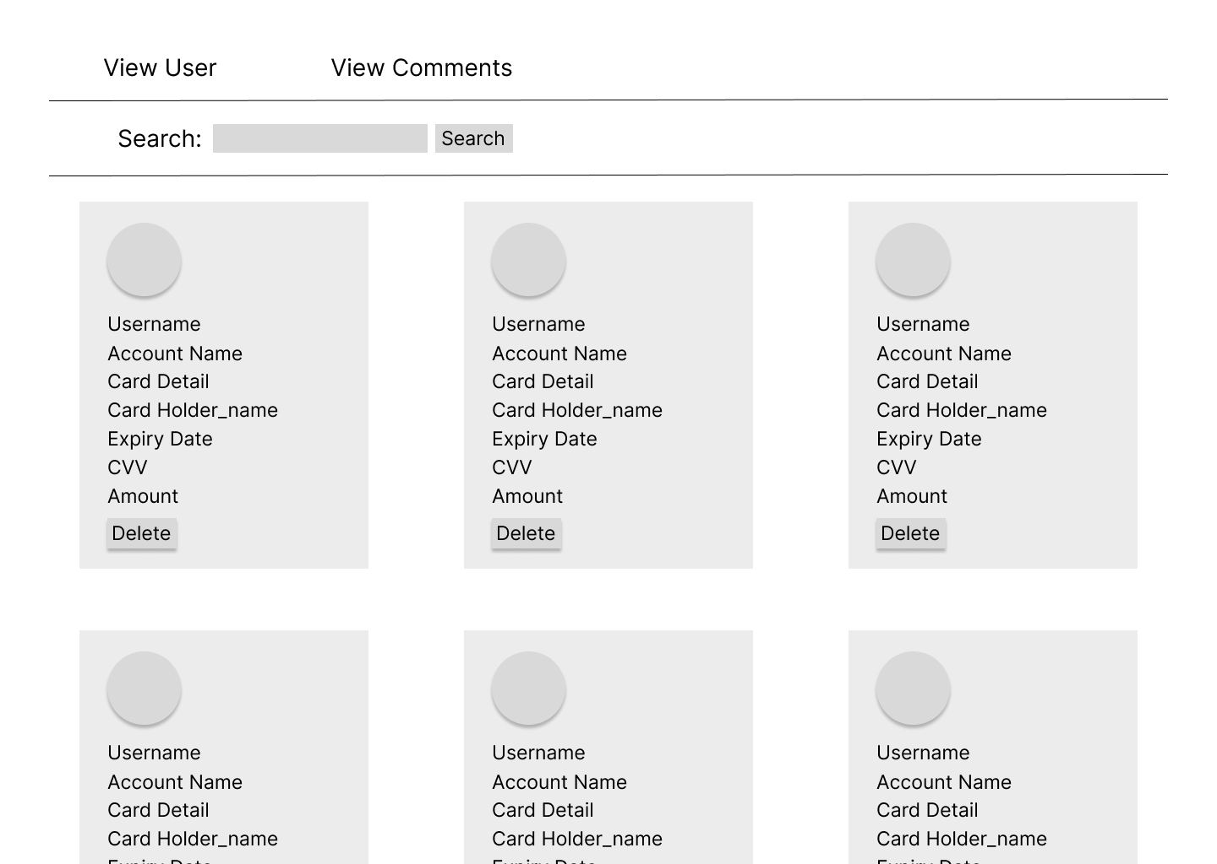

Admin Edit User Page

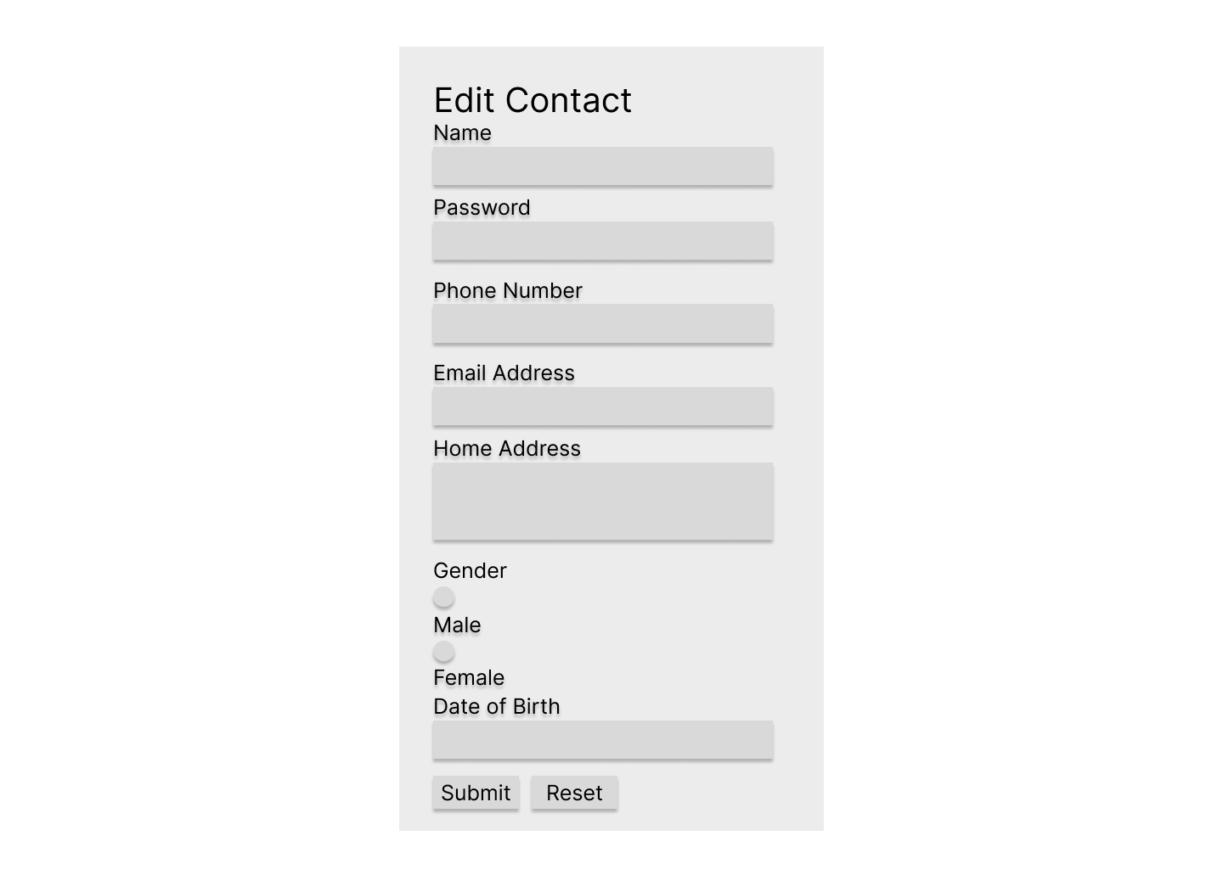

Admin Add Contact Page

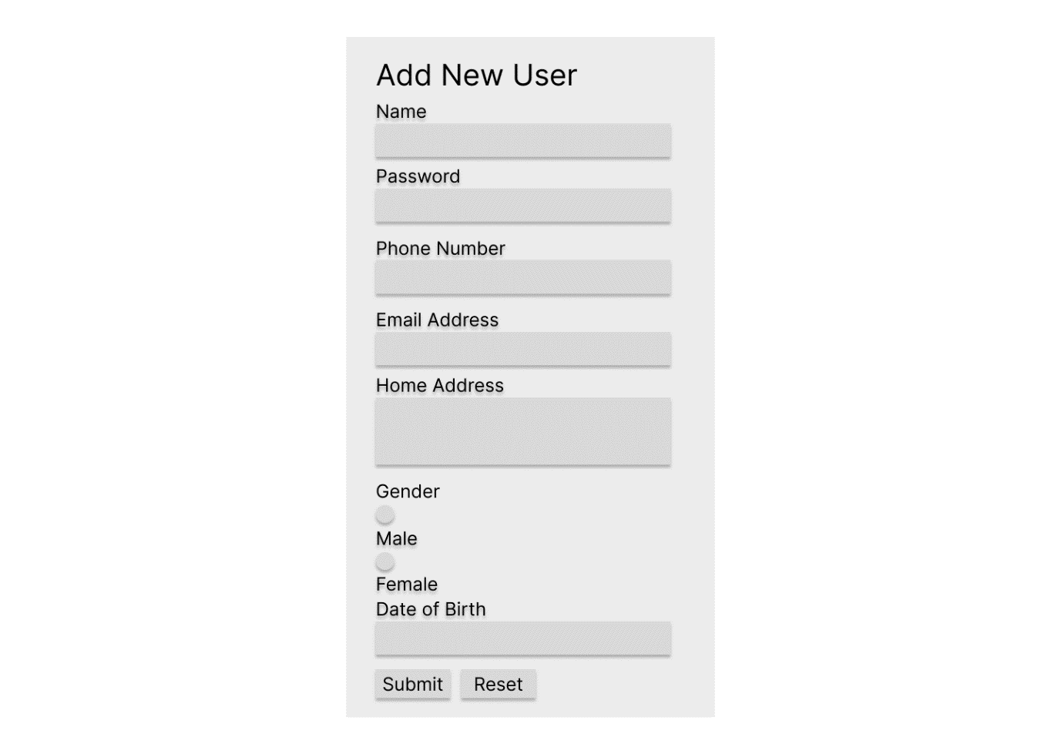

# Implementation

The implementation provides a walkthrough over every single line of code to describe how each individual features of the website works in technical terms.

Login Page

<?php

    session_start();

    if(isset($_POST["LoginBtn"])){

        $conn = mysqli_connect("localhost","root","","assignment");

        $sql = "SELECT * FROM userdetail WHERE user_email = '".$_POST["user_email"]."' AND user_password ='".$_POST["user_password"]."'";

        $result = mysqli_query($conn,$sql);

        $row = mysqli_fetch_array($result);

        if($row){

            $_SESSION["user_id"] = $row["user_id"];

            if(isset($_POST["remember"])){

                setcookie("user_login",$_POST["user_email"],time() + (7 * 24 * 60 * 60),"/");

            } else {

                unset($_COOKIE['user_login']);

                setcookie('user_login', null, -1, '/');

            }

                header("location:userhome.php");

        } else {

            echo"<script>alert('Invalid username/ password!');</script>";

        }

    }

Register Page

<input type="submit" id="submitID" name="submitBtn" value="Submit">

<?php

if(isset($_POST['submitBtn']))

{

    include('conn.php');

    // Sanitize user input to prevent SQL injection

    $name = mysqli_real_escape_string($con, $_POST['name']);

    $username = mysqli_real_escape_string($con, $_POST['username']);

    $phonenumber = mysqli_real_escape_string($con, $_POST['phonenumber']);

    $emailaddress = mysqli_real_escape_string($con, $_POST['emailaddress']);

    $password = mysqli_real_escape_string($con, $_POST['password']);

    $homeaddress = mysqli_real_escape_string($con, $_POST['homeaddress']);

    $gender = mysqli_real_escape_string($con, $_POST['gender']);

    $dateofbirth = mysqli_real_escape_string($con, $_POST['dateofbirth']);

    $user_type = 'member';

    $sql = "INSERT INTO userdetail (account_name, user_name, user_phone, user_email, user_password, user_address, user_gender, user_dob, user_type)

            VALUES ('$name', '$username', '$phonenumber', '$emailaddress', '$password', '$homeaddress', '$gender', '$dateofbirth','$user_type')";

    if (!mysqli_query($con, $sql)){

        die('Error: ' . mysqli_error($con));

    }

    else{

        echo "<script>alert('Successful!'); window.location.href='login.php';</script>";

    }

    mysqli_close($con);

}

else{

    echo "<script>alert('Please fill in the form'); window.location.href='register.php';</script>";

}

?>

Log Out

<?php

session_start();

session_destroy();

echo"<script>alert('Successfully Logout.');window.location.href='home.php';</script>";

?>

# User Guidance

Before Login

Home Page

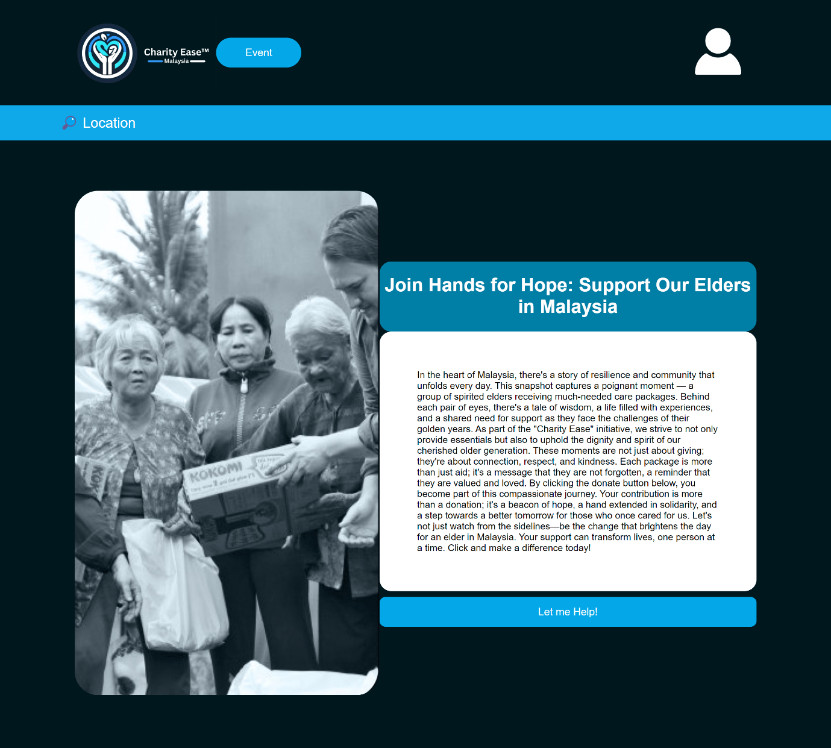

Event Page

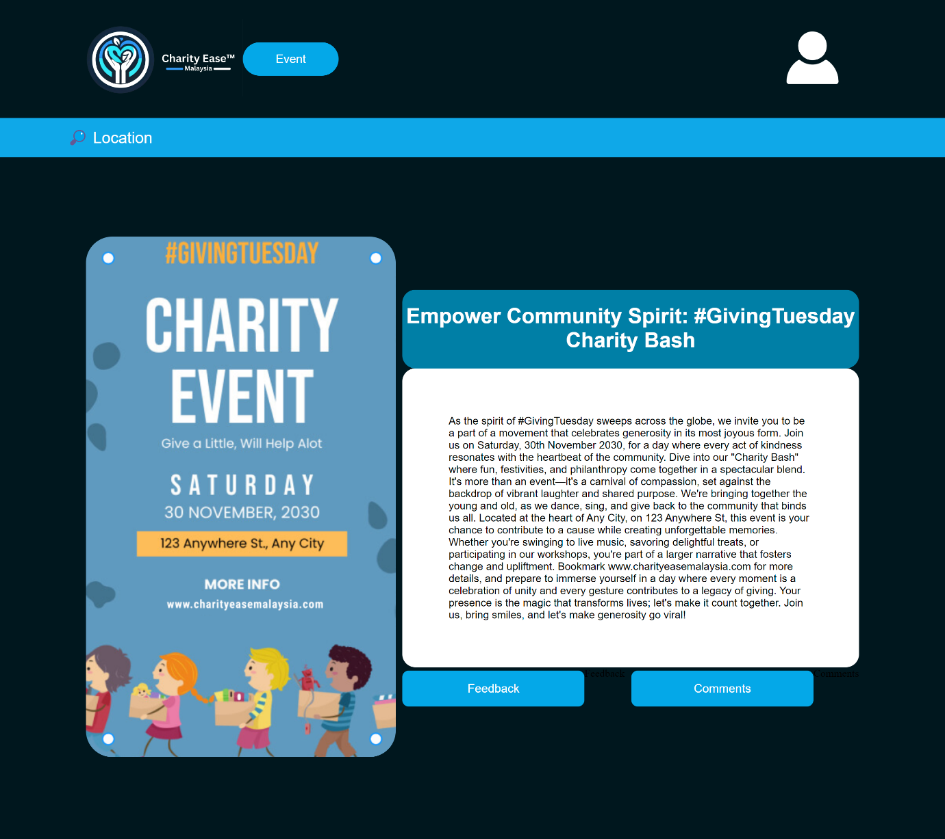

Login Page

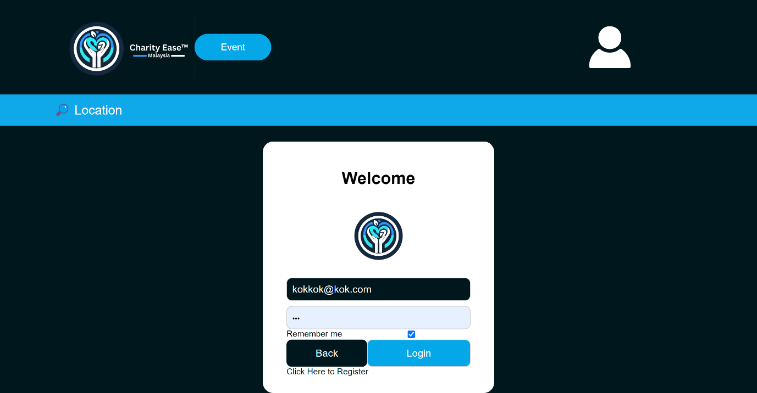

Register Page

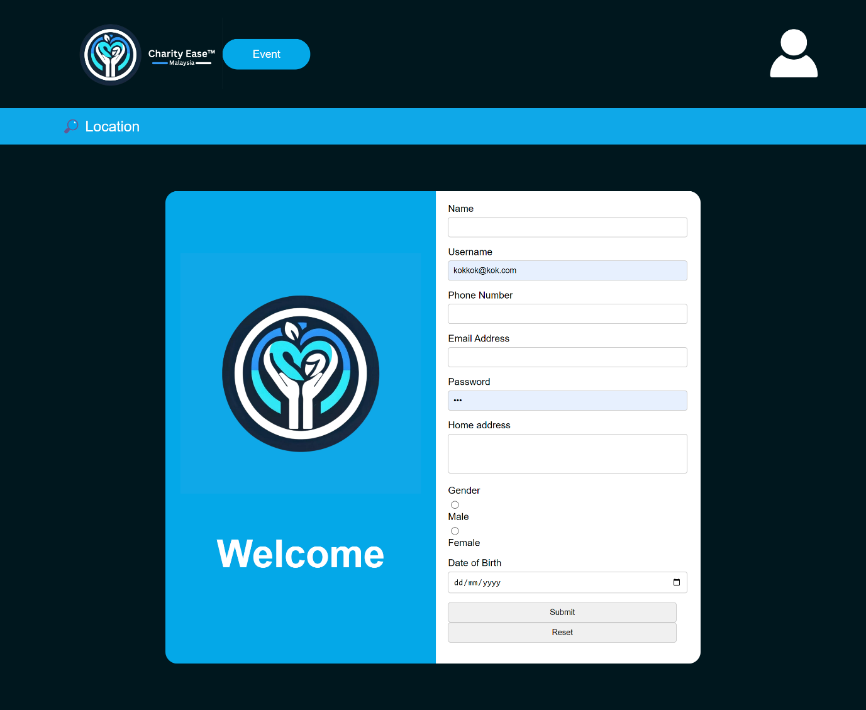

After Login

User Home Page

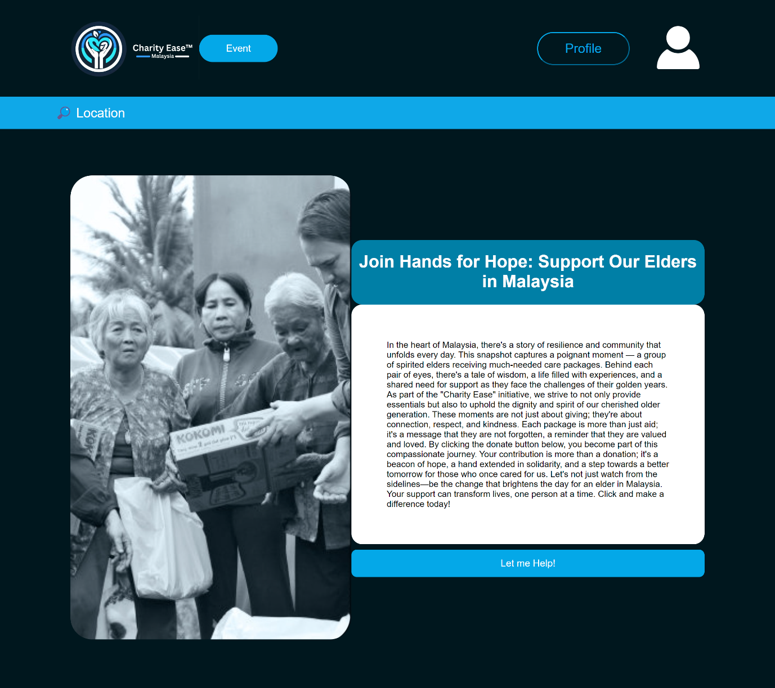

User Event Page

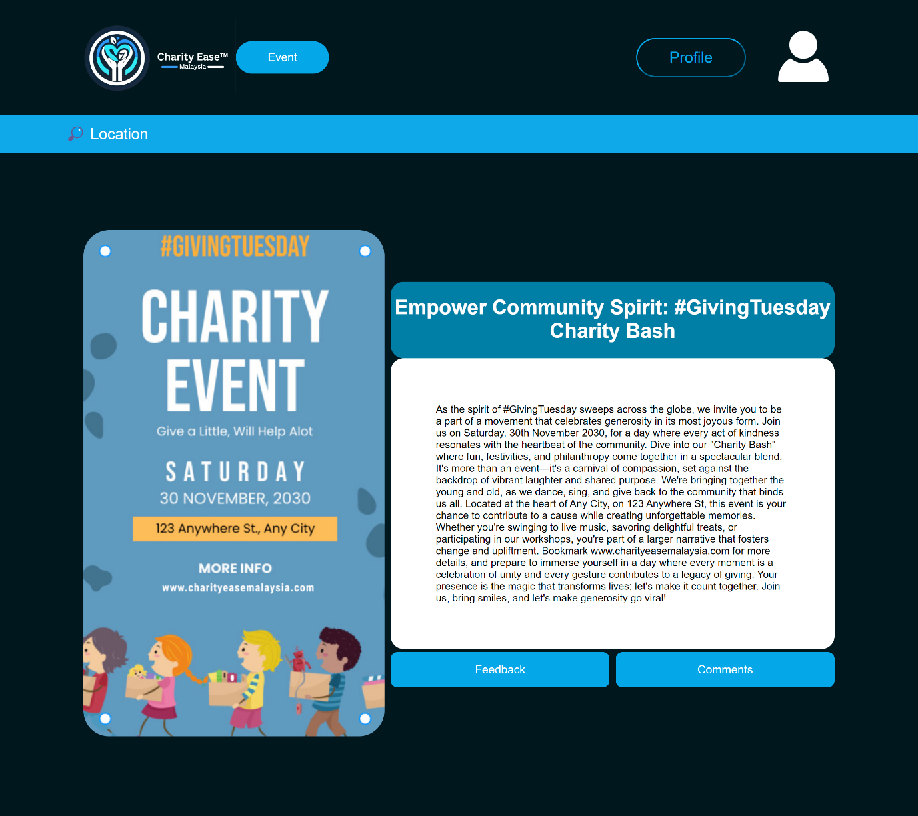

Donation Page

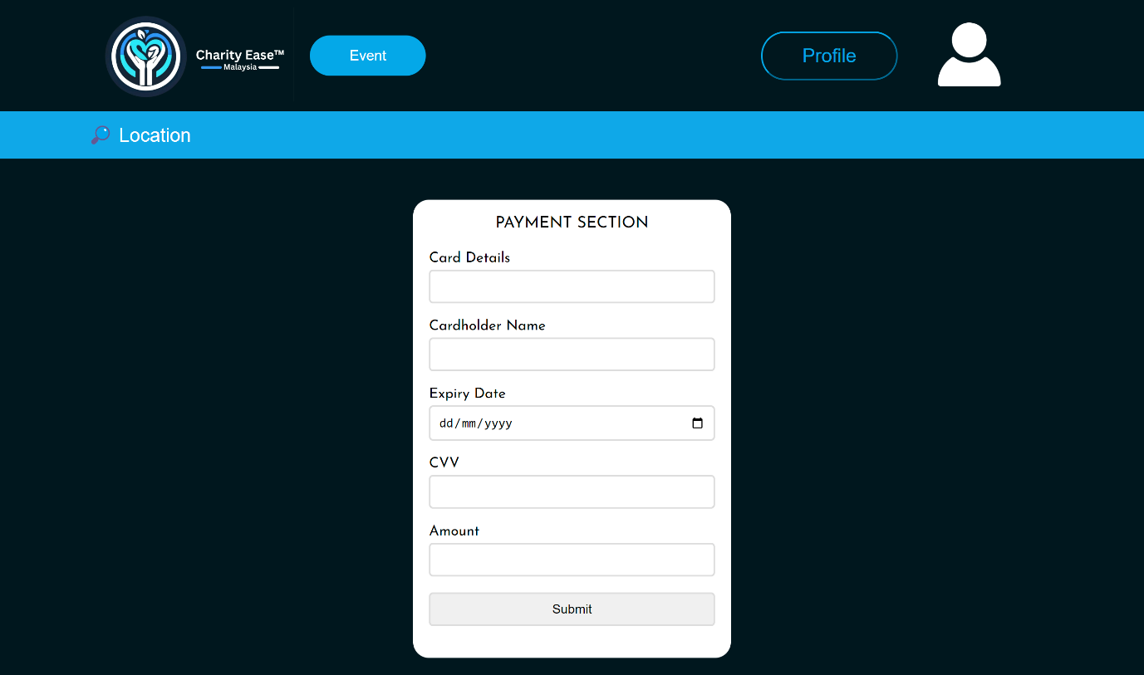

Feedback Page

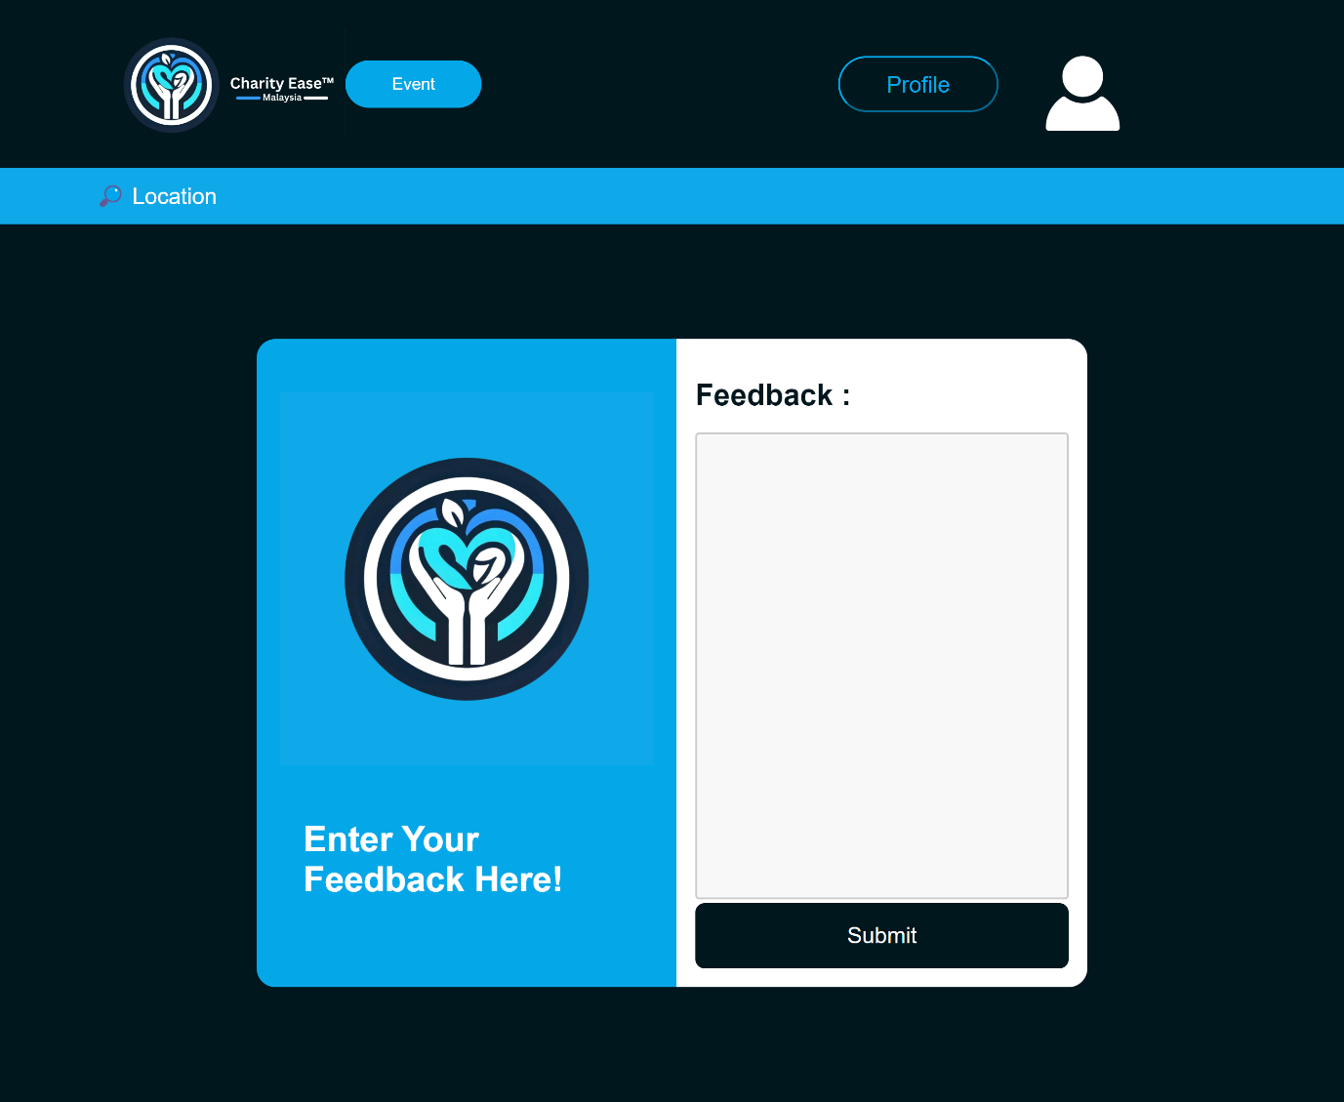

Comment Page

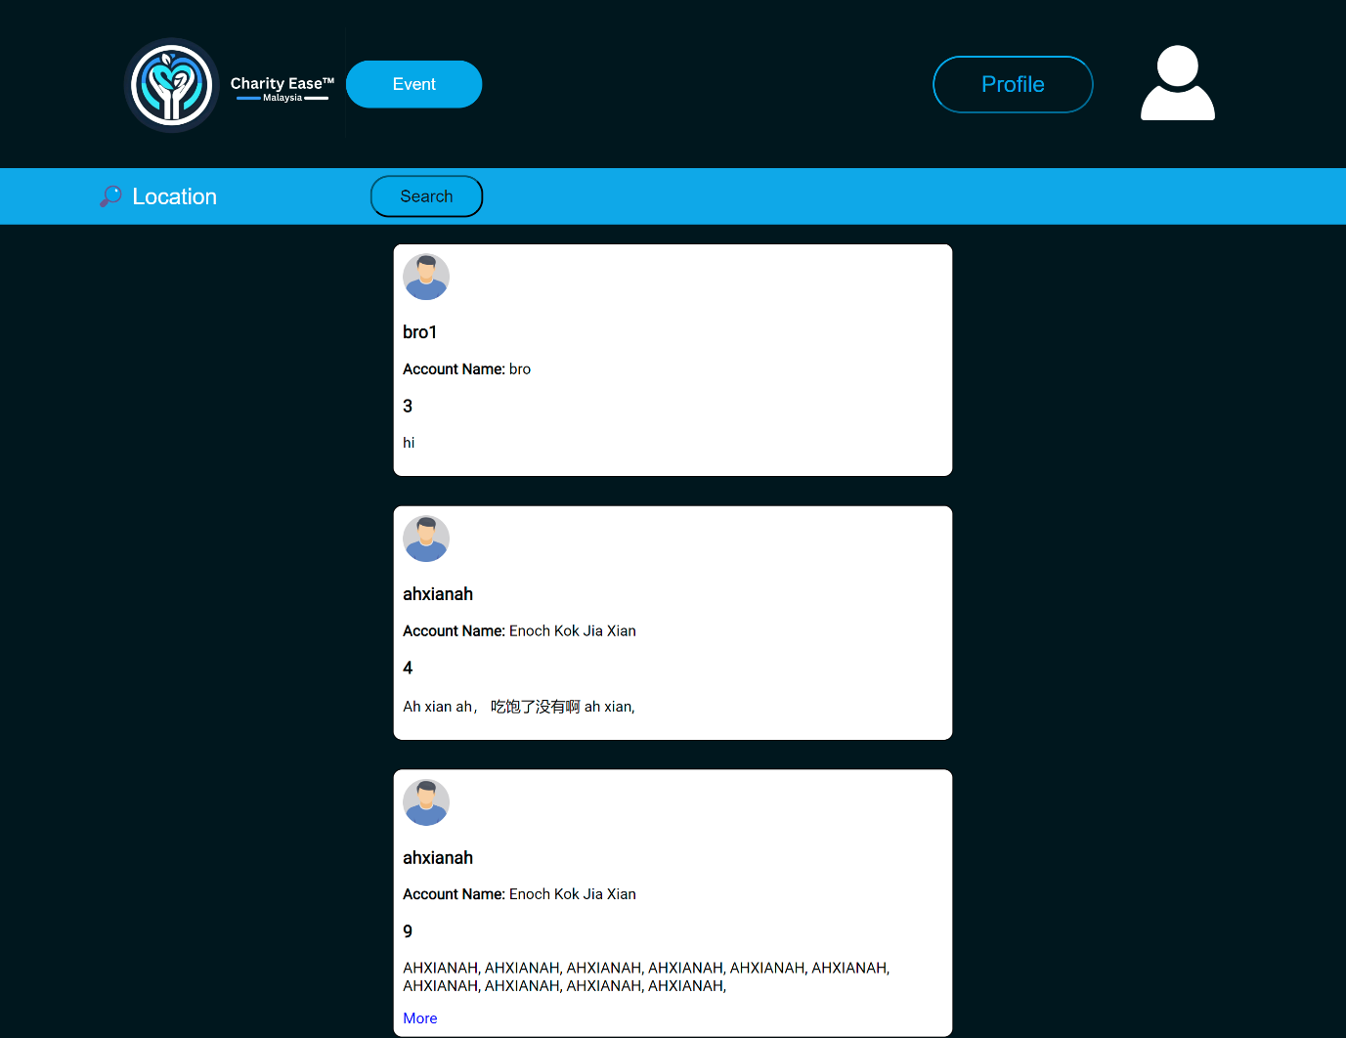

Admin

Admin View User Page

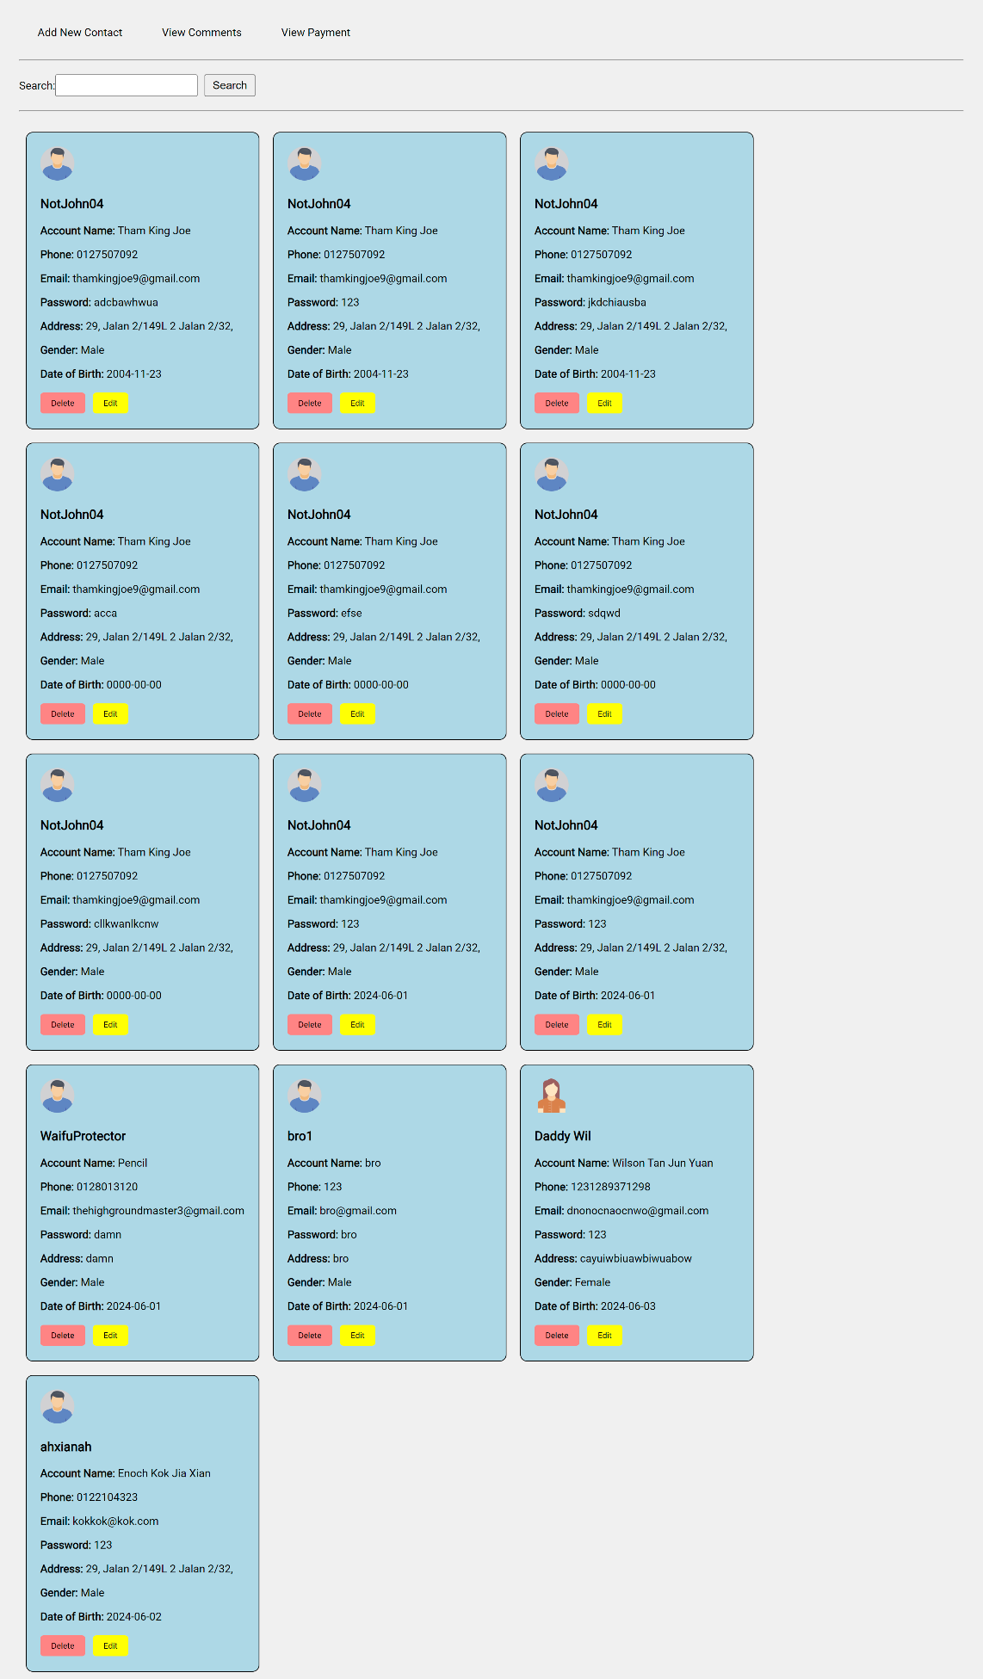

Admin View Payment Page

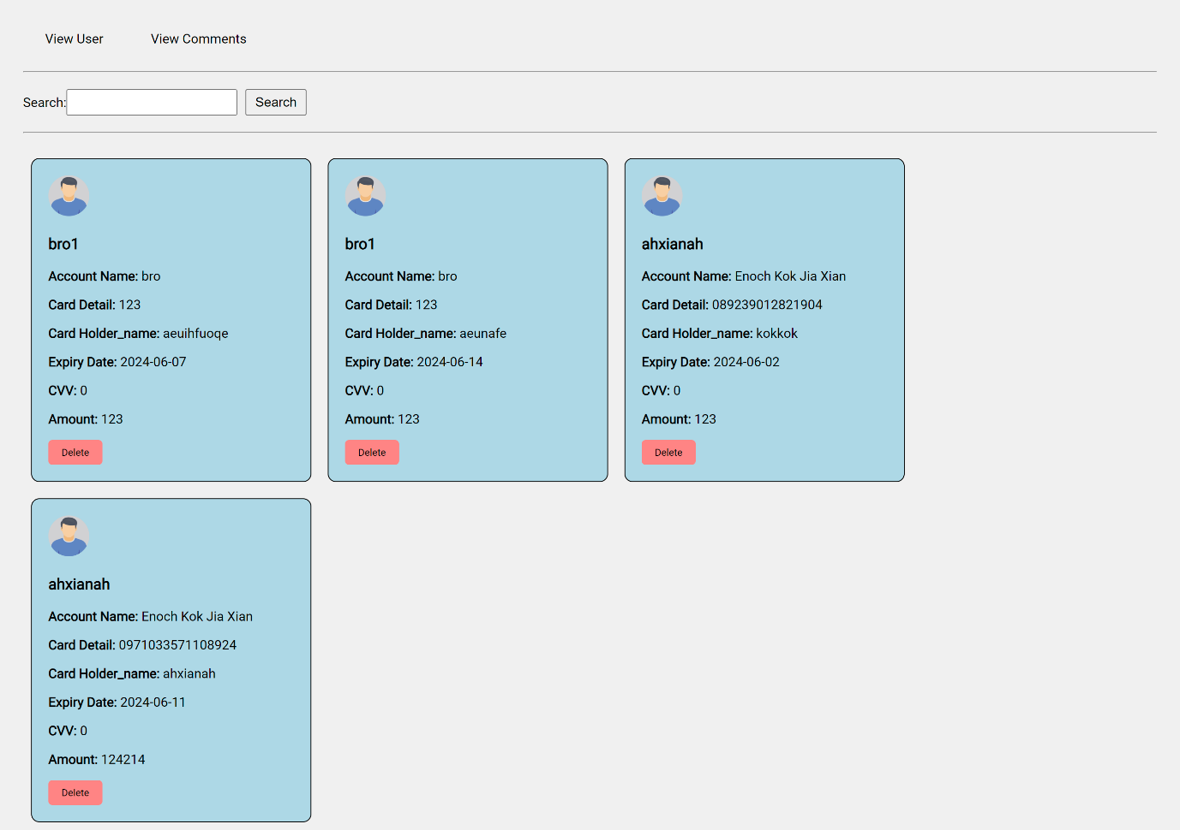

Admin View Comment Page

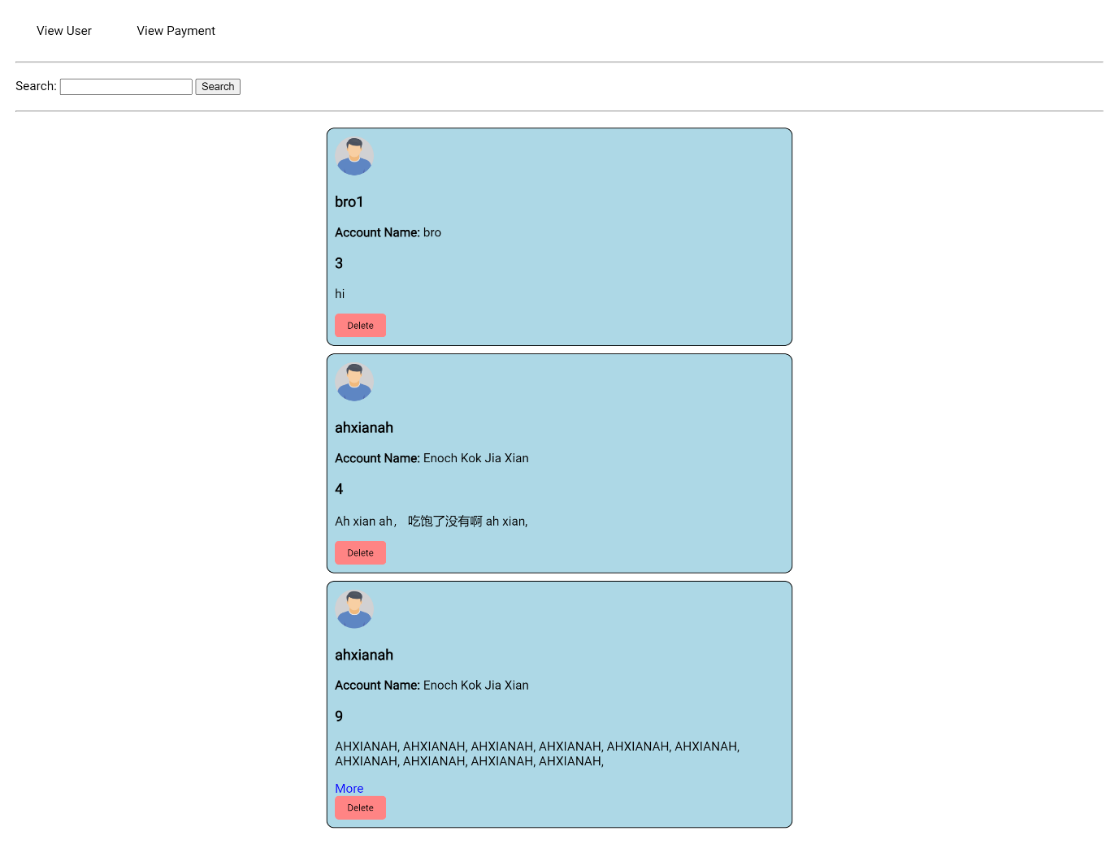

Admin Edit User Page

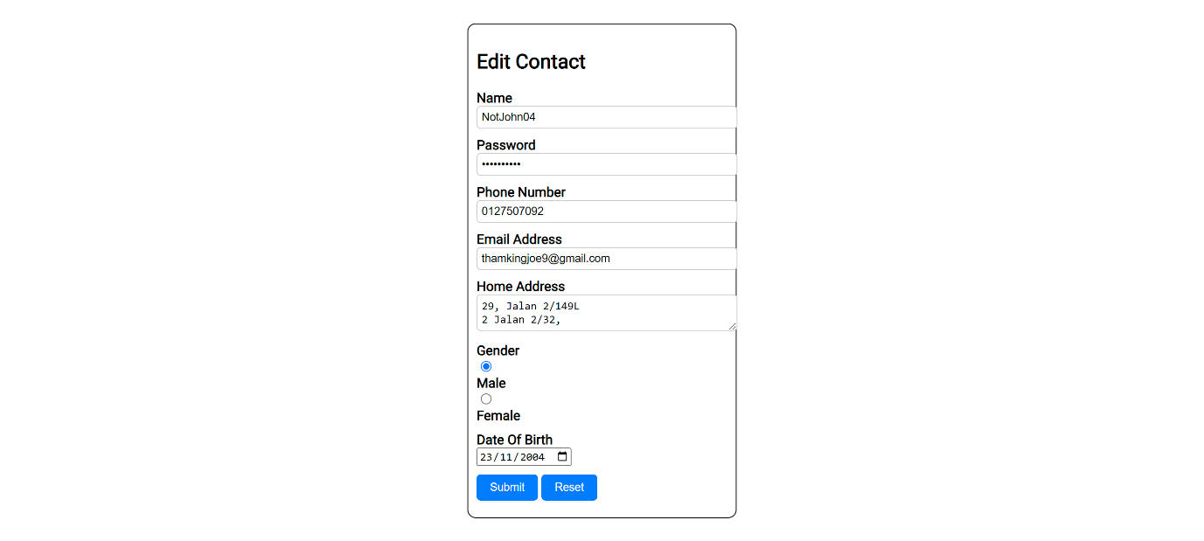

Admin Add New Contact Page

# 

# Conclusion

# References

# Workload Matrix